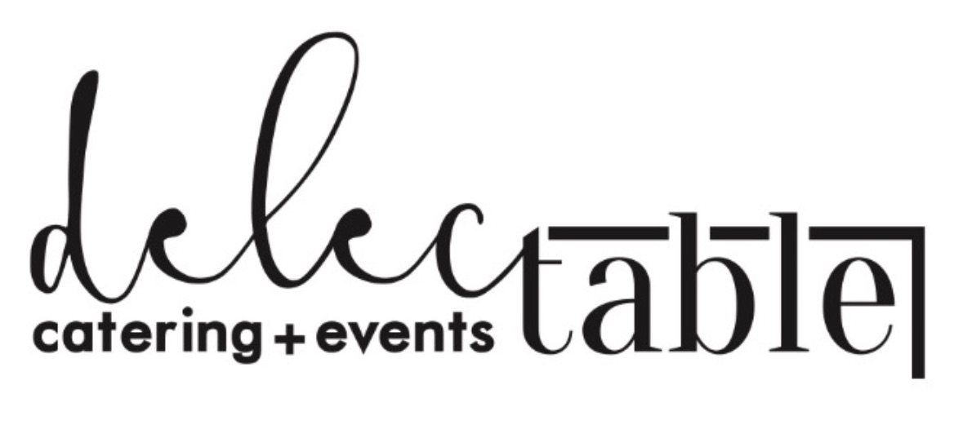

DINNER BUFFET MENUS

Italian Pasta Dinner Buffet

$28.75 with dessert, $25.75 without dessert

\*Classic Caesar salad with house made sourdough croutons, Caesar dressing and freshly shaved parmesan cheese & garnished with fresh lemon

\*Fire roasted seasonal vegetables

\*Penne pasta or Linguini pasta

\*House made Alfredo sauce or marinara sauce

\*Freshly shaved parmesan cheese

\*Grilled sliced chicken breast or Italian sausage

\*Assorted mini desserts

\*strawberry lemonade and iced tea

\*All charges are subject to 19% service charge & 8.7% sales tax



DINNER BUFFET MENUS

Delectable Catering Signature Dinner

$31.75 with dessert, $29.75 without dessert

\* Mixed green salad with pears, candied almonds, craisens, feta cheese & pear vinaigrette & balsamic glaze

\*Fire roasted seasonal vegetables with fresh rosemary and butter

\*Our famous creamy garlic mashed potatoes

\*Warm rolls with butter

\*Grilled chicken breast with garlic and chardonnay sauce

\*Assorted mini desserts

Beverage Station with iced tea, huckleberry lemonade & ice water

\*All charges are subject to 19% service charge & 8.7% sales tax



DINNER BUFFET MENUS

Delectable Catering Signature duet protein dinner

$36.75 with dessert, $33.75 without dessert

\*Classic Caesar salad with house made sourdough croutons, Caesar dressing and freshly shaved parmesan cheese

\*Fire roasted seasonal vegetables with fresh rosemary and butter

\*Our famous creamy garlic mashed potatoes

\*Pacific Salmon baked to perfection & topped with grapefruit buerre blanc

\*Choice cut grilled sirloin steak topped with client’s choice of peppercorn demi glaze or creamy gorgonzola sauce

\*Warm rolls with butter

\*Assorted mini desserts

Beverage Station with Iced tea, Huckleberry lemonade & ice water

\*All charges are subject to 19% service charge & 8.7% sales tax



THEMED STATION MENUS

Chef attended carving station

Choice of two of the following proteins

$18.75 to add to any menu or to include with 2 other stations

\* Chef carved choice sirloin with peppercorn red wine demi or gorgonzola cream sauce

\*Chef carved book salmon with lemon, grapefruit beurre blanc

\*Chef carved honey roasted ham with assorted mustards on the side

\*Chef carved turkey baked to perfection with cranberry sauce & creamy turkey gravy \*served with warm rolls & butter

\*All charges are subject to 19% service charge & 8.7% sales tax

Mashed potato station

Choice of 6 of the following toppings

$17.25 to add to any menu or to include with 2 other stations \* famous creamy garlic mashed potatoes seasoned to perfection \*Choice of toppings to include: shredded cheddar, feta cheese, sliced olives, sour cream Salsa, chives, bacon bits, grilled onions, grilled mushrooms & red peppers



THEMED STATION MENUS

Asian Station

Choice five of the following

$22.75 per person \* Thai lettuce chicken wraps with house made soy sauce \*California rolls with wasabi and fresh ginger \*Vegetable spring rolls with sweet and sour sauce \*Pan fried dumplings with our famous soy lime dipping sauce \*House made white rice with creamy butter \*Chicken satay with Thai peanut sauce \*BBQ pork chilled and served with sesame seeds & assorted dipping sauces

Mediterranean Station

All menu items included in station $20.75 per person \* Antipasto platter with meats, cheeses, peppers, olives, artichokes, cherry tomatoes & baby corns \*Grilled and chilled assorted vegetables with balsamic glaze \*Grilled pita bread with house made hummus and romesco spreads \*Caprese kabobs with fresh mozzarella, cherry tomato, basil & balsamic

\*All charges are subject to 19% service charge & 8.7% sales tax